Wars in Lebanon
Student’s Name
Institutional Affiliation

Wars in Lebanon
International and regional participation has played an integral part in the politics of Lebanon based on the division between the East and West. West and East Beirut are characterized by the differences between Muslims and Christians. Other countries such as Syria, Israel, PLO, and the United States of America (USA) become proactively engaged in the internal affairs of the country in a bid to mitigate the ongoing war. The Lebanese Civil War started in 1975, and Riad is opined that the Americans will come and negotiate on their after armed shooters seized the city (Youssless, 2018). Thus, the movement was at somebody’s own risk. International and regional interventions have been crucial in ensuring that Lebanon obtains national stability and make constitutional reforms.
I think that people reject the nationalist narratives of their rulers based on the movie “West Beyrouth” after realizing that they are trying to turn the country into a war zone. In this regard, rulers are disregarded on the basis of trying to create dysfunctions that impact the citizens negatively. In April 1975, Beirut was plagued with a massacre that leads to the city being characterized by military checkpoints to weed non-Muslim natives (Youssless, 2018).
Besides, I am opined that multi-generational war aided in the political framework of Israel and Lebanon since it has promoted the push for international tribunals. For example, the murder of Rafiq Hariri other highly-esteemed Lebanese politicians has led to the international community to sponsor initiatives aimed at fostering Israeli-Palestinian peace. Dominant players such as Menachem Begin, David Ben-Gurion, and Ariel Sharon from the Israeli font were instrumental in directing the wars against Lebanon. Thus, they played an integral in the acts of violence against the country. For instance, Ariel Sharon agitated for the construction of Israeli residential estates in the Gaza Strip and the West Bank.
In addition, the French possessed considerable influence in Lebanon since they colonized the territory after the Ottoman partition of territories and the end of World War I. In this regard, the French set up the Sectarian system that limited the democratic privileges of the Lebanese. The influence is depicted in the movie from Tarek’s complaints of attending French schools that were the main source of rivalry in the country (Youssless, 2018). Notably, the Palestinian refugee crisis contributed to the political relationship between Lebanon and Israel since the refugees sought homage in the two countries. As a result, they helped them comprehend the ramification of war with regards to the Christian refugee lady, May in the movie. All in all, I think that the movie is trying to show how civil war can cause a country to lose everything.
2.
Link: https://www.middleeasteye.net/discover/syrias-fugitive-theatre-maker-still-making-drama-about-peace-and-freedom
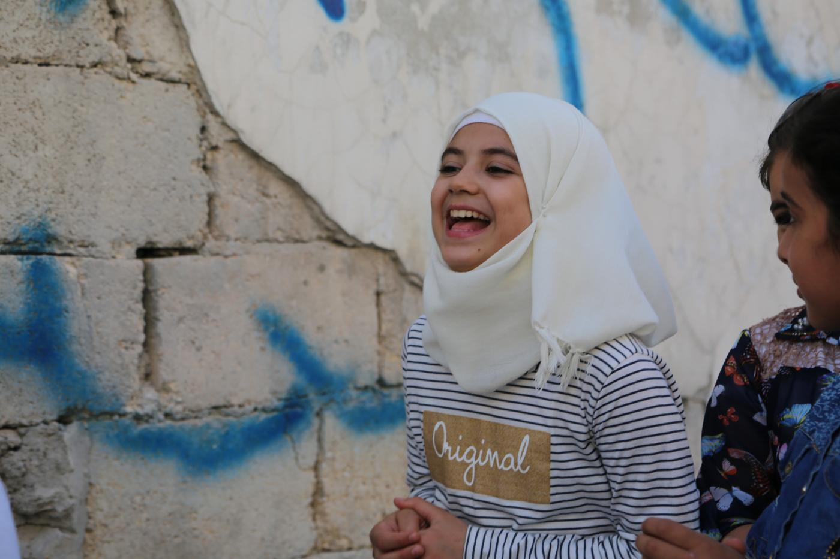
Link: https://www.unhcr.org/news/latest/2009/6/4a323b686/iraqi-refugees-release-captivating-album-online.html
I have learned from the source that Syrian refugees in Lebanon are using dram to send the message of peace within the region. The drama is inspired by Salman Ibrahim, and the children are captured performing the piece known as “The only Dignity.” The play is focused on how conflicts have paralyzed Syria. The theme of the drama oriented towards how government and rebel groups had contributed to the crisis being experienced in Syria. I have learned from the phenomenon above that in spite of the challenges that people face in life; despair should not be an option. In this regard, people can use art in the form of drama to create awareness about the issue and inspire radical changes within society. Also, I have learned that children play an integral part in the mitigation of crises within the country. Children are the next generation, and they provide a reason where the adults have failed. Children can be used to instill a sense in the minds of the leaders since they are among the vulnerable populations during wars. Children’s campaigns for peace can induce emotions in the hearts of the people in a bid to show them that there is a need for change in certain circumstances
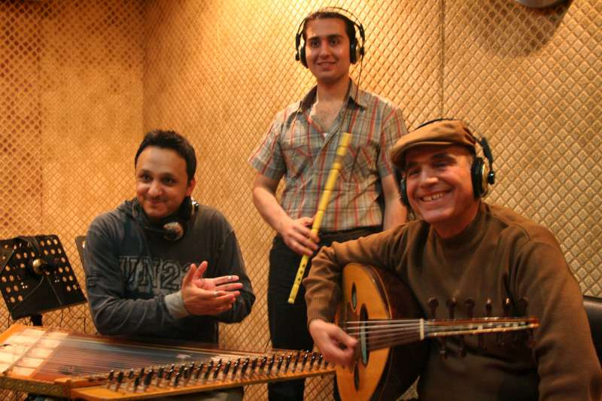
The source describes how Iraqi refugees released a captivating album within social sites with the aid of UNHCR. The music was shared in digital streaming sites showing a trio of refuge seekers. The refugees reiterated that they were inspired to release the album since they wish to use the proceeds to help financially-unstable compatriots. The music was based on their day-to-day experiences as refugees. The music incorporated diverse music elements with regards to contemporary creations and Iraqi cultural characteristics. The three had met in Damascus after they had fled from Iraq due to the prevalence of war. I have learned that music can be used constructively to create unity and peace among warring factions. Thus, music creates extensive awareness of the issues affecting society in a bid to initiate change. Besides, I have learned music shared on social sites can draw the attention of the masses on what is happening in a particular part of the world. As a result, activist musicians can garner support from the rest of the world that is likely to respond by contributing food and monetary resources. The contributions can aid their cause of helping the victims of war.

Reference
Youssless. (2018). West Beirut (full movie). [Online]. YouTube. Retrieved from
https://www.youtube.com/watch?v=dCkQ7qC0C6I

